**K8s in Production**

**Create a 3-node (1 control-plane, 2 worker nodes) Kubernetes Cluster.**

**All three VMs should have containerd, kubeadm, kubelet, kubectl installed**

**Process:**

**Set Up AWS Resources**

Logged in to AWS Management Console.  
• Launched 3 EC2 Instance: (virtual machine - Ubuntu).

And security groups to allowed HTTP (port 80) and SSH (port 22) traffic with instance type - T2.medium and 15Gb disk size and created PPK file.

Master Node and two worker nodes

**Connect to Your EC2 Instance**

•    Used SSH to connect to EC2 instance using the PPK file via Putty.

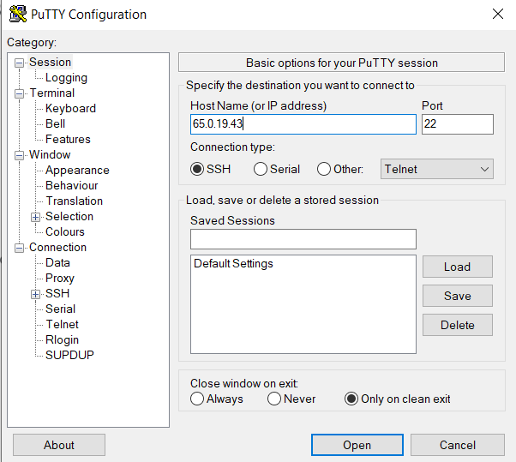

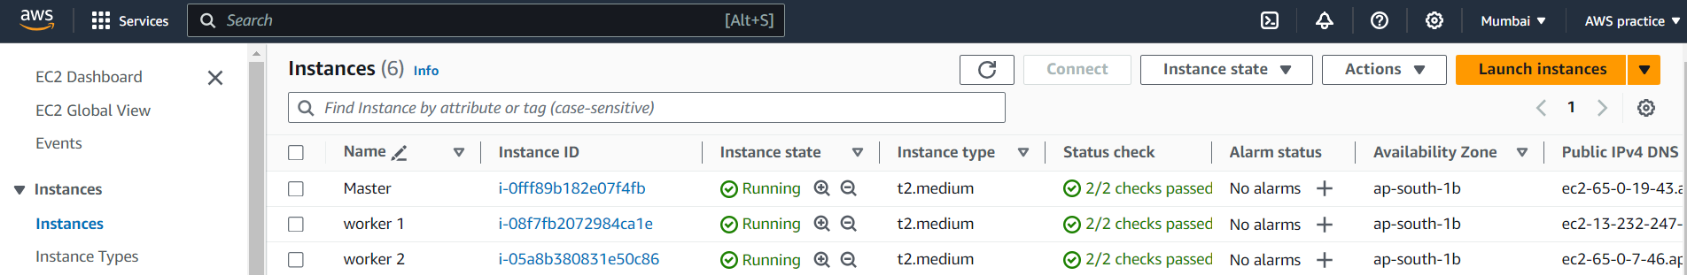

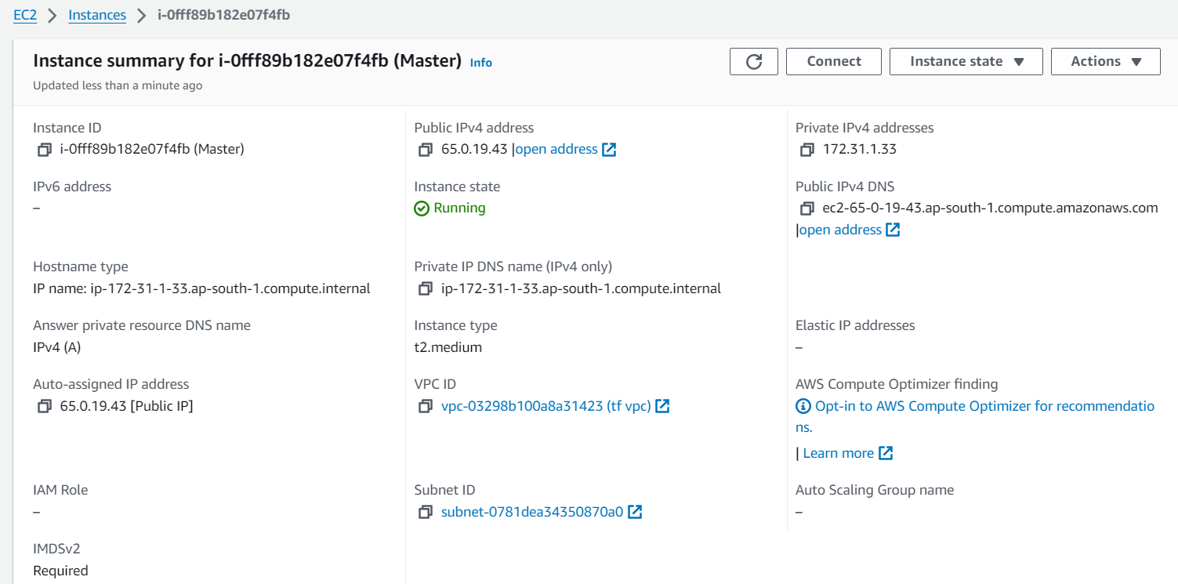

Updated the system's package list and install necessary dependencies using the following commands on three (Master and worker machines)

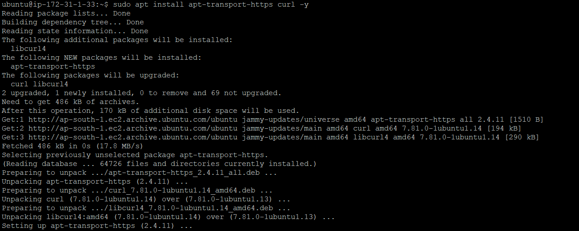

Installed Containerd, used the following commands(Applied to all machine)

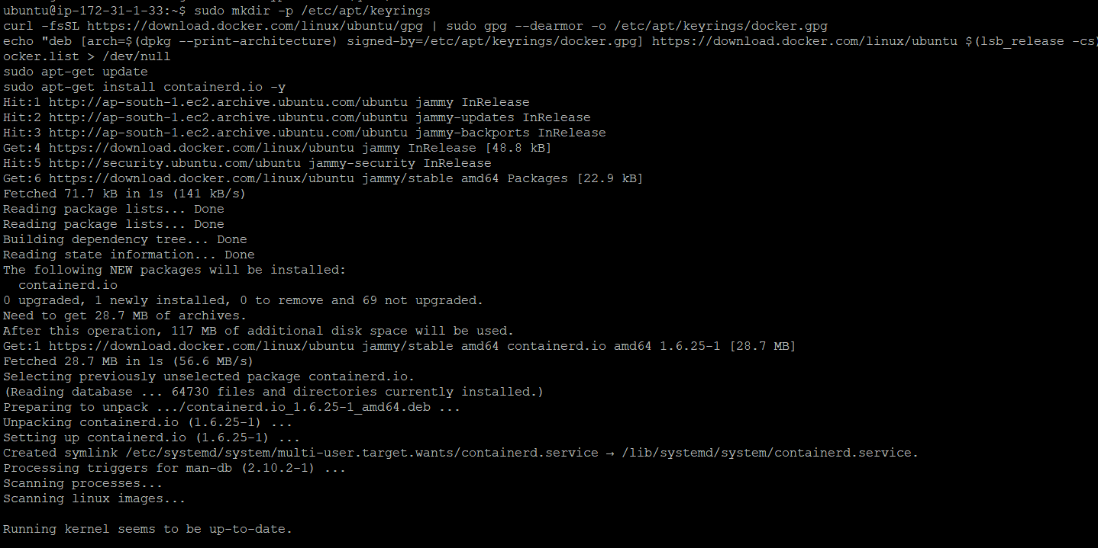

created the containerd configuration file using the following commands:(On three machine)

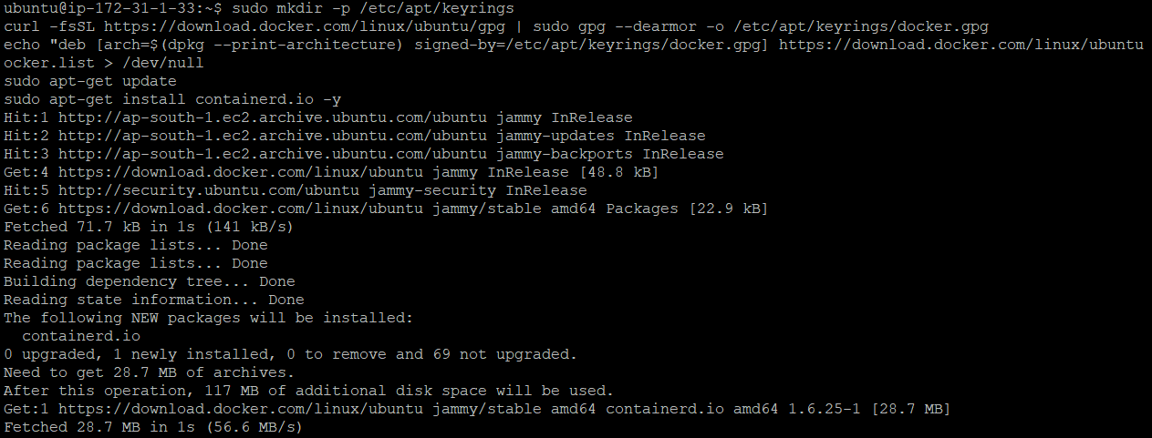

Edited the containerd configuration file to set SystemdCgroup to true. Used the following command to open the file:(Apply to all machine)

Setted SystemdCgroup to true:

SystemdCgroup = true



Restart containerd(Over all machines)



Installed Kubernetes on three machines(Master and worker nodes), use the following commands:

curl -s https://packages.cloud.google.com/apt/doc/apt-key.gpg | sudo apt-key add

sudo apt-add-repository "deb http://apt.kubernetes.io/ kubernetes-xenial main"

sudo apt install kubeadm kubelet kubectl kubernetes-cni

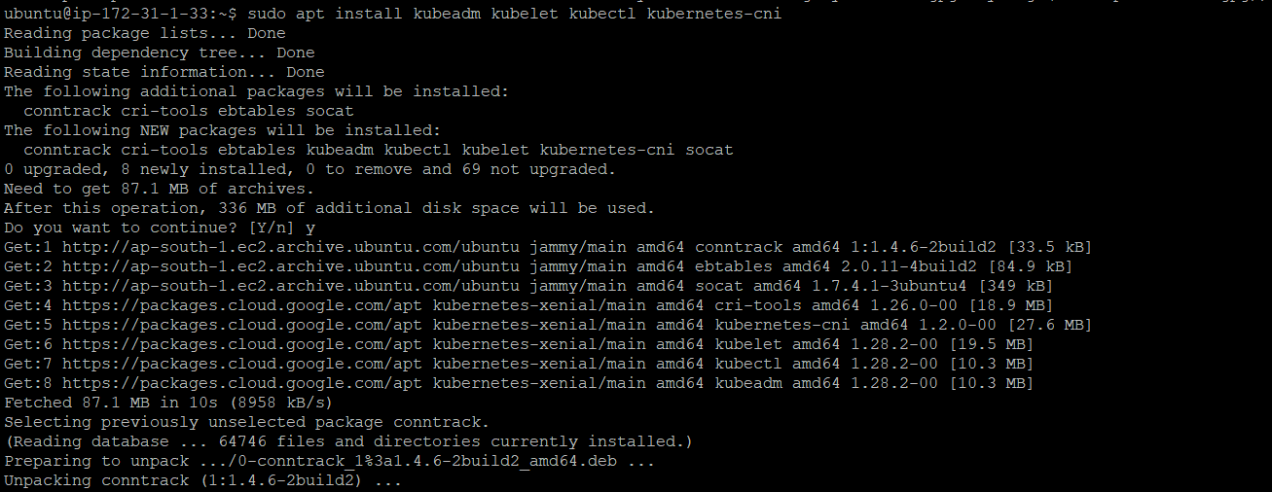

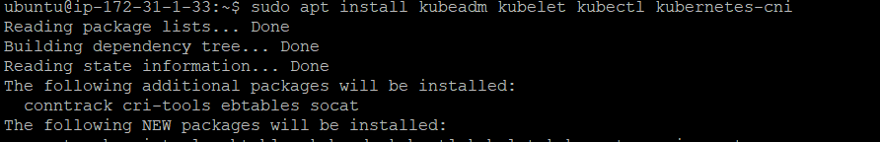

Disabled swap on master machine: :(Apply on three machines)

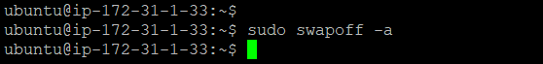

If there are any swap entries in the /etc/fstab file, remove them using a text editor :(Apply on three machines)



Enabled kernel modules using following command:(Apply on three machines)

* sudo modprobe br_netfilter



Added some settings to sysctl using below command: (Apply on three machines)



## Initialized the Cluster (only on master) using following command:

## sudo kubeadm init --pod-network-cidr=10.244.0.0/16

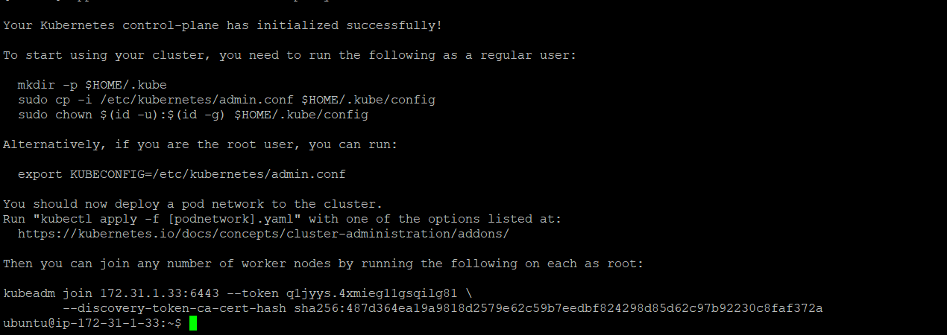

Created a .kube directory in home directory,Copied the Kubernetes configuration file to home directory and Changed ownership of the file:

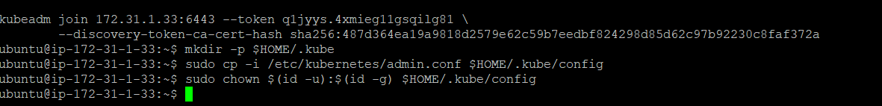

## Installed Flannel (Run only on master)

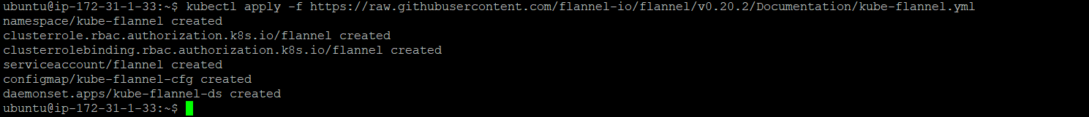

After installed flannel we got the running master node as below.



Verified that all the pods are up and running:

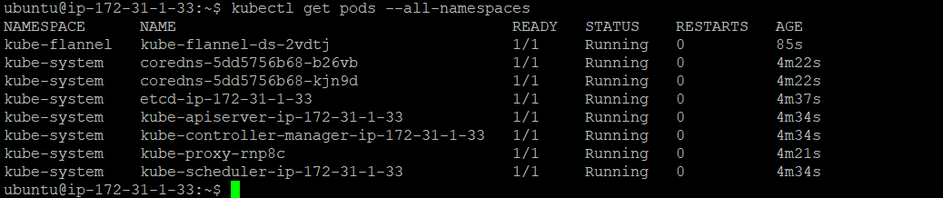

Got token by initialized cluster:

**kubeadm join 172.31.1.33:6443 --token q1jyys.4xmieg11gsqilg81 \**

**--discovery-token-ca-cert-hash sha256:487d364ea19a9818d2579e62c59b7eedbf824298d85d62c97b92230c8faf372a**

To add nodes to the cluster, run the kubeadm join command with the appropriate arguments on each node. The command will output a token that can be used to join the node to the cluster as below:

Worker 1

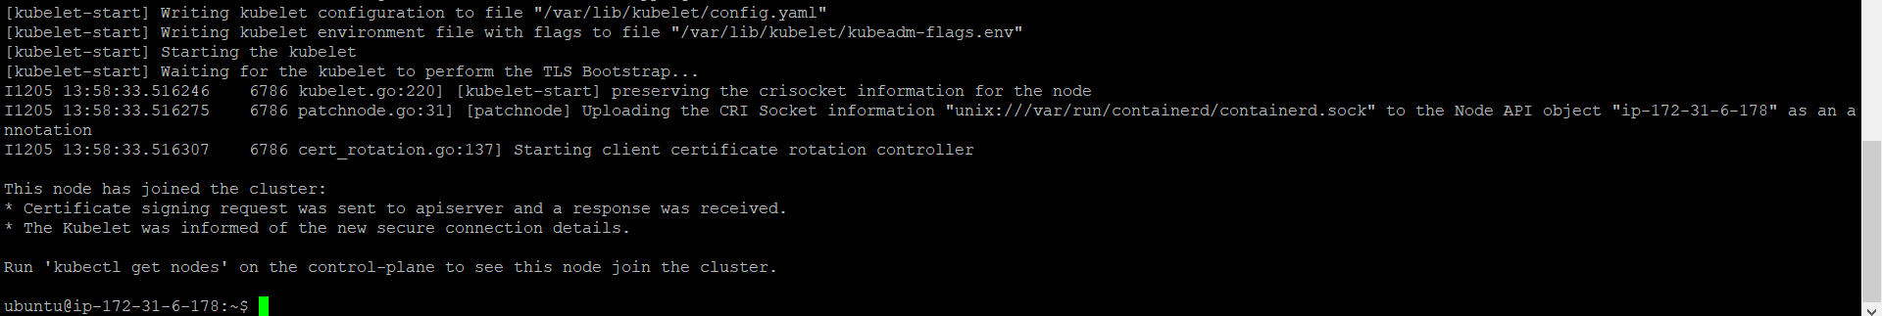

Worker 2

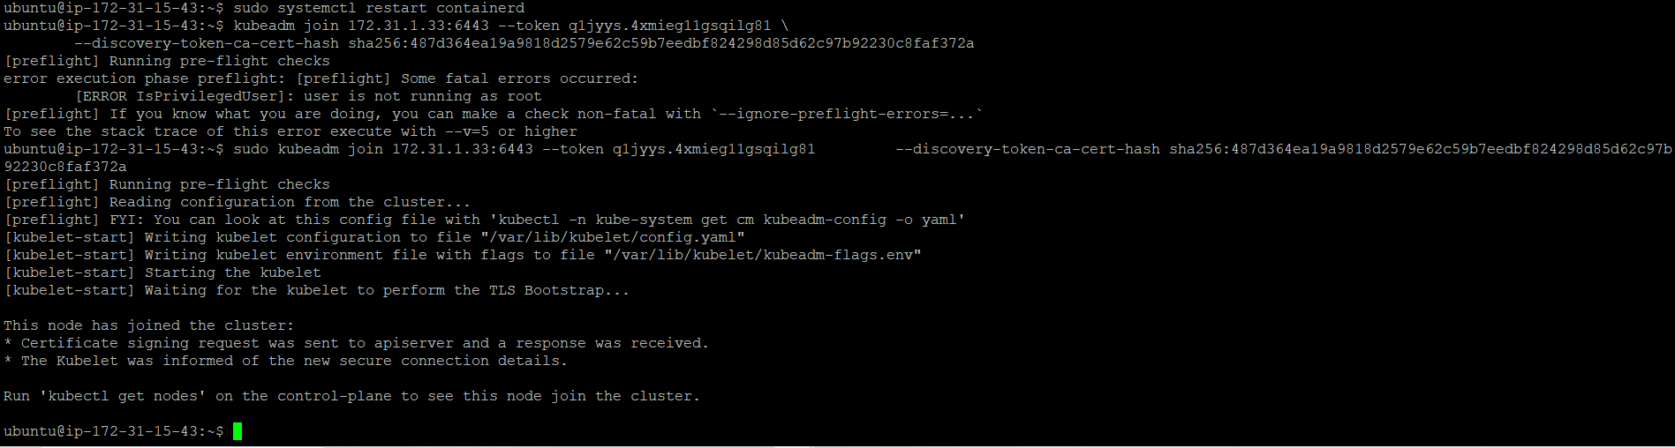

After successful run we got the nodes on master machine and ensured that the 3 cluster node cluster created properly:

